Hermes Windows 10; Bruker Linux Windows 10

NOTE1 Text styles:
- Console command pipelines are printed like this (I also indicate if/what environment they are supposed to run). Where necessary, command prompt commands are preceded by the console prompt (e.g., c:\Users\xxx>) to make it clear what they are; see below for details.
I use the following notation to indicate the user’s home directory:
for command prompts: %userprofile%
for bash shells: ~
Drive_letter:path> command pipeline e.g., C:\Users\xxx> setx …
For example:
C:\Users\xxx> setx …
This example can also be also written as
%userprofile%> setx …
  - For the regular command prompt within an active python virtual environment:
(environment_name)Drive_letter:path> command pipeline e.g., (scipyenv)c:\
  - For the VisualStudio2019 (VS19) x64 command prompt (a.k.a x64 Native Tools Command Prompt for VS 2019):
(x64)Drive_letter:path> command pipeline
  - VisualStudio2019 (VS19) x64 command prompt INSIDE python virtual environment
(x64)(environment_name) Drive_letter:path> command pipeline
  - Other consoles (e.g. Git cmd, etc) will similarly indicate this, e.g.
(Git)
(mingw-w64)
(Qt6) or (Qt5)
  - For Bash consoles I will similarly indicate which bash is executed. NOTE that the bash prompt is by default the user@machine [environment] path followed by ‘$’ on the next line (in Windows):
xxx@MACHINE_NAME [environment] ~
$
Where environment may be MINGW64 etc, depending on which GNU toolkit is being used.
For brevity I will discard the top user@machine [environment] path in the notations:
    - The Cygwin64 terminal
(cygwin) $
    - The MinGW Shell (mingw32)
(mingw32) $
    - The Git Bash (full prompt indicates MINGW64 environment)
(git) $
- Code snippets
Programming language source code is also shown like this, optionally, with a syntax highlighting scheme when possible.
comments inside code snippets and following console commands are preceded by # (command prompt & python code) or // (C++ code); Do NOT enter them at the command prompt!
- Menu items
Menu navigation (e.g. in VS2019) is shown like this: File/Open/Folder…
- Unless specified, ALL console commands are to be entered in the regular Windows command prompt (cmd.exe) – that is, neither PowerShell, nor any of the specialized consoles you may have installed (e.g., VisualStudio, Qt shell, MinGW shell, and so on…). When specialized command prompts or bash shells are used, they are indicated as above.

NOTE2: Setting/adding to PATH environment variable.
You will find the use of setx command to add to the PATH environment variable permanently. This is generally, NOT recommended. Instead, use command script files (*.bat) to add to PATH dynamically when required. If however, adding to PATH permanently IS needed, then the MOST SECURE way to do this is to use the corresponding Control Panel (open Settings, the search for “environment”, then select “Edit environment variables for your account”.
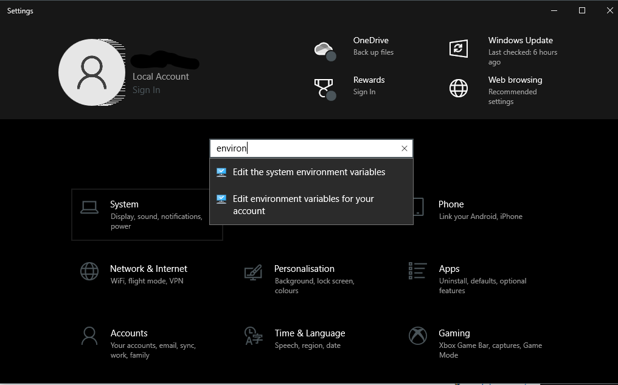
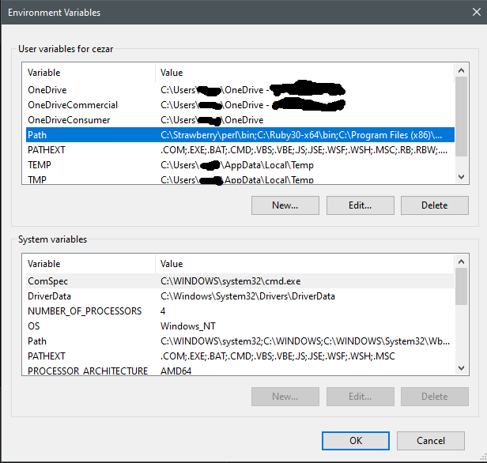
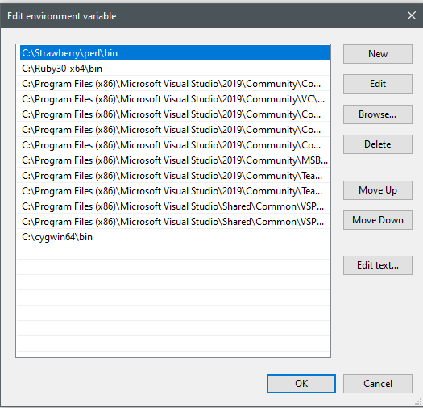

Install VisualStudio Community Edition 2019
From the installer, choose to install C++ development and Windows 10 SDK (needed to build Qt).
This is required to build boost and VIGRA libraries.
Boost is required to build vigranumpy (Python bindings for VIGRA).

Install Python3
Install python3 for windows – you may be able to get the Python3 app from Windows Store, or (better) directly from https://www.python.org/ . The latter support better integration with bash etc and also offers to disable the 256 character limit for PATH environment variable (make sure you activate this from the GUI installer provided).
After installing Python from python.org, you should be able to see the following in a regular command prompt:
%userprofile%>where python
%userprofile%\AppData\Local\Programs\Python\Python39\python.exe
%userprofile%\AppData\Local\Microsoft\WindowsApps\python.exe
Where %userprofile% is the path to your home directory (e.g. C:\Users\xxx)

Install git, GitHubDesktop, gh
git: From https://git-scm.com/download/win choose the installer (setup) for the 64 bit version and install.
GitHubDesktop: download Windows 64 bit installer from here https://desktop.github.com/
gh cli: download from https://cli.github.com/

Download boost:
Below are instructions for Boost 1.77.0 (latest). The Boost “root” directory is where the Boost distribution is installed.
Because several Boost version can co-exist, they are all placed inside c:\boost.
Without admin rights it is better to place then inside %userprofile%. In the following, admin rights are assumed.
Hence, the “root” boost directory in this example is:
c:\boost\boost_1_77_0
When in doubt, see “Get Boost”:
https://www.boost.org/doc/libs/1_77_0/more/getting_started/windows.html#get-boost
- Install 7-zip (typically, from the MS Windows store).
- Download Boost 7z archive (see “Get Boost”)
- Extract the boost archive using Win7zip àextract to c:\boost
C:\boost\boost_1_77_0
NOTE: Boost “root” directory is the one shown above.
- Using VS 2019, compile and run the example in “Get Boost” to check it all works.

Compile boost binary libraries.
Boost is mostly header files – no compilation needed – except for some libraries which need to be built locally. To build vigranumpy, later, the boost-threads, boost-python, boost-chrono will be required. Here, we decide to build all binary libraries available.
- Follow the instructions in “Get Boost”. Briefly:
cd c:\boost\boost_1_77_0 # go to the boost root directory
c:\boost\boost_1_77_0>bootstrap # prepares the Boost.Build engine
.\b2 # builds the binary libraries
- When built is successful you should see, in the console output:
The Boost C++ Libraries were successfully built!
The following directory should be added to compiler include paths:
C:\boost\boost_1_77_0
The following directory should be added to linker library paths:
C:\boost\boost_1_77_0\stage\lib
Make a note of this because this will be needed when using VS to build code based on Boost.

Install fftw3 libraries and headers
- Download the 64-bit version from https://www.fftw.org/install/windows.html e.g., fftw-3.3.5-dll64.zip
- Extract the archive to c:\fftw3 à this should contain the files inside the downloaded archive, NOT the directory auto-generated by the zip extraction! The files are dynamic libraries – or “application extensions” (*.dll), Windows executables (*.exe), export definition files (*.def) Fortran files (*.f, *.f03), and the fftw3 header (fftw3.h) alongside license (COPYING, COPYRIGHT) and brief instructions (README, README-bench, README-WINDOWS, NEWS). Read at least README-WINDOWS before proceeding.
- According to that page:
These DLLs were created by us, cross-compiled from GNU/Linux using MinGW; the 64-bit version is possible thanks to the mingw-w64 project. You should be able to call them from any compiler. In order to link to them from Visual C++, you will need to create .lib "import libraries" using the lib.exe program included with VC++. Run:
lib /def:libfftw3-3.def
lib /def:libfftw3f-3.def
lib /def:libfftw3l-3.def
On Visual Studio 2008 in 64-bit mode, and possibly in other cases, you may need to specify the machine explicitly:
lib /machine:x64 /def:libfftw3l-3.def
  - From Windows Start menu, navigate to VisualStudio submenu and launch the x64 Native Tools Command Prompt for VS 2019
  - go to the fftw3 directory, and create object file libraries (*.lib), and exports libraries (a.k.a, “object files”) (*.exp) for ALL versions
(x64)C:>cd c:\fftw3
(x64)c:\fftw3>lib /machine:x64 /def:libfftw3-3.def
(x64)c:\fftw3>lib /machine:x64 /def:libfftw3f-3.def
(x64)c:\fftw3>lib /machine:x64 /def:libfftw3l-3.def

Install Qt5 libraries
https://wiki.qt.io/Building_Qt_5_from_Git#Getting_the_source_code

Qt5 prerequisites (on Windows):

Ruby installer
rubyinstaller-devkit-3.0.2-1-x64.exe from https://rubyinstaller.org/downloads/
Selection option 3 in the shell that pops up (install MSYS and MinGW development toolchains)
Set path to ruby executable (this should be taken care of by the installer):
%userprofile%> setx PATH “%PATH%;C:\Ruby30-x64\bin”

Clang
This is optional (only required to build qdoc documentation) and is skipped here – for online Qt documentation go to https://doc.qt.io/qt-5/

ICU
Required to build Qt Webkit.
See detailed instructions here: https://wiki.qt.io/Compiling-ICU-with-MSVC
ATTENTION: The command prompts in the examples on the web site above say “C:\>”. This is WRONG: all the console commands below (point 4) MUST BE EXECUTED INSIDE THE icu\source directory !!!
Briefly:
- Install Cygwin (from https://www.cygwin.com/ download setup-x86_64.exe) – make sure you search for and select 'make', 'dos2unix' and 'binutils'; installs in C:\Cygwin64
  - Do not delete the installer – you will have to call it again to install/update/remove components
- Skip the ICU data library customizer
- Unzip the icuc_54_2_src; move the icu directory inside into your src directory and rename it to icuc_54_2_src.
- Open a new VS2019 X64 command prompt:
cd %userprofile%\src\icuc_54_2_src\source
- Run:
(x64) set PATH=%PATH%;C:\Cygwin64\bin
(x64) dos2unix *
(x64) dos2unix -f configure
(x64) bash runConfigureICU Cygwin/MSVC -prefix=/cygdrive/c/icu/dist
  - WARNING: if you have installed a WSL enviornment, turn this feature OFF or else it will interfere with cygwin’s own bash
  - C:\cygwin64\bin\bash runConfigureICU Cygwin/MSVC -prefix=/cygdrive/c/icu/dist
=== Important Notes: ===
Data Packaging: library
This means: ICU data will be linked with ICU. A shared data library will be built.
To locate data: ICU will use the linked data library. If linked with the stub library located in stubdata/, the application can use udata_setCommonData() or set a data path to override.
Building ICU: Use a GNU make such as make to build ICU.
checking the version of "make"... 4.3 (we wanted at least 3.80)
ok

If the result of the above commands looks okay to you, go to the directory
source in the ICU distribution to build ICU. Please remember that ICU needs
GNU make to build properly...
(x64) make // this will start the compilation
Your may run into a compilation error regarding __iob_func() not being found/defined/exported in ufile.c, line 70
Edit this file (icuc_54_2_src\source\io\ufile.c)
Line 70 is part of the snippet:
#if _MSC_VER >= 1400
//result->fFile = &__iob_func()[_fileno(f)]; // ß OFFENDING LINE
result->fFile = __acrt_iob_func(_fileno(f)); // Cezar Tigaret cezar.tigaret@gmail.com
#else
result->fFile = &_iob[_fileno(f)];
#endif

and replace THE OFFENDING LINE WITH the next one as shown above, then run make again (If you mess up the source code, delete the directory and unpack the source archive again)
(x64) make install // to install à installs in c:\icu
CAUTION the built distribution is c:\icu\dist

ANGLE – dealt with by Qt5 distribution

Perl
Install Strawberry Perl (as recommended by the qt wiki page above) à use the recommended MSI installer file; will install in C:\Strawberry
Hint: If you installed git with the non-recommended setting to add git's entire Unix environment to PATH, make sure that Perl is added to the path in front of git, since that ships an incompatible build of perl, which would cause the scripts to fail. Also, MinGW builds of Qt become Msys builds due to the presence of sh.exe; and those who've tried have had more success configuring and building for MinGW in MS's cmd.exe Command Prompt than in the Git Bash shell.
Alternatively, try c:\cygwin64\perl.exe (not used here)
By default Strawberry will set the correct path to perl excutable into your PATH environment variable

Install jom to be used instead of nmake
If you want to speed up compilation (on multi-core machines)
Get it from here Jom - Qt Wiki
Unzip it to create C:\jom

Install Win64 open SSL (non-light version)
Get it from here: Win32/Win64 OpenSSL Installer for Windows - Shining Light Productions (slproweb.com)
Grab the 140Mb installer (either *.exe or *.msi) for Win64 OpenSSL v3.0.0 – this is the non-light installer.

Clone the Qt5 git repository
%userprofile%>mkdir src
%userprofile%>cd src
%userprofile%\src>git clone git://code.qt.io/qt/qt5.git
%userprofile%\src>cd qt5
%userprofile%\src\qt5>git checkout 5.12
%userprofile%\src\qt5>perl init-repository --module-subset=default,-qtwebengine

Configure VisualStudio to build Qt5
NOTE: Below is the snipper from the Wiki page (link above). Adapt it to your actual situation (e.g. where Qt5 source tree is located, and all other paths). For Windows10 replace <arch> with amd64.

Configuring Visual Studio 2013 on Windows 8, 8.1 & 10
Setting the environment variables to properly build Qt can be done by following the steps below:
- Create a file called qt5vars.bat, paste the following inside it and save it
Hint: Remember to change <arch> to your desired platform and double-check that the paths are correct for Qt and Visual Studio
@echo off
REM Set up \Microsoft Visual Studio 2015, where <arch> is amd64, x86, etc.
CALL "C:\Program Files (x86)\Microsoft Visual Studio\2019\Community\VC\Auxiliary\Build\vcvarsall.bat" amd64
REM Edit this location to point to the source code of Qt
SET _ROOT=%userprofile%\src\qt5
SET PATH=%_ROOT%\qtbase\bin;%_ROOT%\gnuwin32\bin;%PATH%
REM Uncomment the below line when using a git checkout of the source repository
SET PATH=%_ROOT%\qtrepotools\bin;%PATH%
REM Uncomment the below line when building with OpenSSL enabled.
REM If so, make sure the directory points to the correct location (binaries for OpenSSL).
REM SET PATH=C:\OpenSSL-Win32\bin;%PATH%
SET PATH=C:\C:\Program Files\OpenSSL-Win64\bin;%PATH%
REM When compiling with ICU, uncomment the lines below and change <icupath> appropriately:
SET INCLUDE=C:\icu\include;%INCLUDE%
SET LIB=C:\icu\lib;%LIB%
SET PATH=C:\icu\lib;%PATH%
REM Add path to jom.exe
SET PATH=C:\jom;%PATH%
REM Contrary to earlier recommendations, do NOT set QMAKESPEC.
SET _ROOT=
REM Keeps the command line open when this script is run.
cmd /k
Complete the steps below after you have cloned Qt5 from Git
- After having cloned Qt5 from Git (assuming it's at C:\Qt5), move qt5vars.bat to the Qt5 folder
- Double-click on the script to run it. Once it runs the script, the command prompt will stay open to enter additional commands.
- Navigate to C:\Qt5 in the command prompt
The working directory should be c:\Qt5.
All the required environment variables are now correctly set up and building Qt5 with nmake should work now. You have to run qt5vars.bat and use the command prompt every time you build Qt5 with nmake.
The above steps also work for setting up nmake to build jom.

Configure Qt5 for building
See https://doc.qt.io/qt-5/configure-options.html for details about Qt’s configure executable
Double-click on qt5vars.bat; use the command prompt window launched by it. You will have to create a separate, yet completely parallel build tree (i.e. same depth, and on the same drive) – e.g., assuming the qt5 source tree is %userprofile%\src\qt5 then the build tree MUST be %userprofile%\src\qt5-build
(x64) path_to_qt_souce_tree>cd ..
(x64) path_to_qt_souce_tree>mkdir qt5-build
(x64) path_to_qt_souce_tree>cd qt5-build
(x64) path_to_qt_build>
(x64) path_to_qt_build>..\\qt5\configure -developer-build -opensource -nomake examples -nomake tests -mp –opengl es2 -confirm-license
This will configure the build to be used directly from the build tree (no need for installation). Alternatively, as used on DEFINE Ephys 3.59, the build can be configured to install in a separate directory, and to use some of the libraries that come bundled in Qt:
(x64) path_to_qt_build>..\\qt5\configure –prefix c:\qt5 -opensource -nomake examples -nomake tests -mp –opengl es2 -confirm-license –qt-zlib –qt-libjpeg –qt-libpng –qt-freetype –qt-pcre –qt-harfbuzz -no-qtlocation

Build Qt5
(x64) path_to_qt_build>jom
Finally, if using alternative configure options:
(x64) path_to_qt_build>nmake install # in this example, it will install in C:\qt5
In the latter case you should add c:\qt5\bin to the PATH, permanently (see NOTES at the top of this document).
Test the build … to be done

Create a Python3 virtual environment

Install Python3
See above – Install python3 for windows
NOTE that Scipyen is developed on Python 3.6.13 for Linux (with ipython 7.16.1 being the highest version supported by that version of Python). I have had issues building a more recent version of Python on my machines (not enough time to figure out why). So, if Scipyen works on Python 3.9, that’s fine. Just DO NOT DEVELOP Scipyen CODE using Python3.9/IPython >= 7.16.1-specific features!

Install virtualenv as user

Install virtualenv:
- In a command prompt run:
C:\Users\xxx>pip3 install virtualenv
- Make directory ‘Scripts’ in the user’s directory
C:\Users\xxx>mkdir Scripts
- Add Scripts to the %PATH% environment variable PERMANENTLY (for this user only):
C:\Users\xxx>setx path “%path%;%userprofile%\Scripts
NOTE:
To verify:
C:\Users\xxx>echo %path%
C:\Users\xxx>echo %PATH%
Both do the same thing (environment variable names are case-insensitive)
%userprofile%
Resolves to the user’s ‘home’ directory (C:\Users\xxx)
- In the Scripts directory create a file ‘scipyact.bat’ with the following contents:
@echo off
%userprofile%\scipyenv\Scripts\activate
echo on

NOTE:
If %userprofile% resolves to a folder with spaces the expansion won’t do. Replace it with the full path to activate, enclosed in quotations marks, e.g.:
“C:\DEFINE Ephys 3.59\scipyenv\Scripts\activate”
Also, the scipyen environment can be created anywhere in the file system provided the user has read-write access to that location.

Hereafter, the location of scipyenv (including the scipyenv directory itself) is shown as %scipyenv%. So, following the example above, %scipyenv% might expand to (remember to place it between quotes, if needed):
C:\DEFINE Ephys 3.59\scipyenv

Activate the virtual environment
In a new command prompt type ‘scipyact‘ to activate the new environment à the prompt becomes:
(scipyenv) C:\Users\xxx>
ATTENTION: Hereafter, execution of console commands INSIDE the scipyenv environment will be flagged with the (scipyenv)prefix.

Install sip v.5
Extract sip-5.5.1.dev2011271026.tar.gz
(seems to work in the regular command prompt?)
(scipyenv) %scipyenv”>cd sip-5.5.1.dev2011271026
(scipyenv) sip-5.5.1.dev2011271026> python setup.py build
(scipyenv) sip-5.5.1.dev2011271026> python setup.py install

Install PyQt5
Extract PyQt5-5.15.3.dev2012141313.tar.gz .
(scipyenv) %scipyenv”>cd PyQt5-5.15.3.dev2012141313

Configure PyQt5
# NOTE: this will use qmake which relies on some environment variables (with their own defaults). Among these, the following need adapting to point to the virtual python environment (lines below are for Unix OS, Windows counterpart is shown below)
# QT_INSTALL_PLUGINS resolves to /usr/lib64/qt5/plugins
# QT_INSTALL_DATA resolves to /usr/share/qt5
# therefore the designer plugin dir, qml plugin dir and qsci api dir must be manually
# mentioned
# By default these are:
--designer-plugindir=QT_INSTALL_PLUGINS/designer
--qml-plugindir=QT_INSTALL_PLUGINS/PyQt5
--qsci-api-destdir=QT_INSTALL_DATA/qsci
#
# Replace
# QT_INSTALL_PLUGINS with $VIRTUAL_ENV/lib/qt5/plugins/
# QT_INSTALL_DATA with $VIRTUAL_ENV/share/qt5
On Windows these are (assuming installation in c:\qt5):
qmake -query
QT_SYSROOT:
QT_INSTALL_PREFIX:c:/qt5
QT_INSTALL_ARCHDATA:c:/qt5
QT_INSTALL_DATA:c:/qt5
QT_INSTALL_DOCS:c:/qt5/doc
QT_INSTALL_HEADERS:c:/qt5/include
QT_INSTALL_LIBS:c:/qt5/lib
QT_INSTALL_LIBEXECS:c:/qt5/bin
QT_INSTALL_BINS:c:/qt5/bin
QT_INSTALL_TESTS:c:/qt5/tests
QT_INSTALL_PLUGINS:c:/qt5/plugins
QT_INSTALL_IMPORTS:c:/qt5/imports
QT_INSTALL_QML:c:/qt5/qml
QT_INSTALL_TRANSLATIONS:c:/qt5/translations
QT_INSTALL_CONFIGURATION:
QT_INSTALL_EXAMPLES:c:/qt5/examples
QT_INSTALL_DEMOS:c:/qt5/examples
QT_HOST_PREFIX:c:/qt5
QT_HOST_DATA:c:/qt5
QT_HOST_BINS:c:/qt5/bin
QT_HOST_LIBS:c:/qt5/lib
QMAKE_SPEC:win32-msvc
QMAKE_XSPEC:win32-msvc
QMAKE_VERSION:3.1
QT_VERSION:5.12.11
Therefore, to configure PyQt5 on windows you need to do as below ( %VIRTUAL_ENV% has been set up by scipyact, see above).
NOTE
- you must run this from the x64 command prompt (activate scipyenv in the VS2019 x64 developer command prompt).
- It may be a Good Idea ™ to augment the scipyact script:
@echo off
REM Set up \Microsoft Visual Studio 2015, where <arch> is amd64, x86, etc.
CALL "C:\Program Files (x86)\Microsoft Visual Studio\2019\Community\VC\Auxiliary\Build\vcvarsall.bat" amd64
"C:\Users\DEFINE EPhys 3.59\scipyenv\Scripts\activate"
echo on

Configure PyQt5:
(x64, scipyenv) PyQt5-5.15.3.dev2012141313> python configure.py --confirm-license --link-full-dll --no-python-dbus --link-full-dll --designer-plugindir=%VIRTUAL_ENV%\Lib\qt5\plugins\designer --qml-plugindir=%VIRTUAL_ENV%\Lib\qt5\plugins\PyQt5 --no-qsci-api

If in trouble, run:
(x64) PyQt5-5.15.3.dev2012141313> python configure.py –help

Now, make & install the thing.
(x64, scipyenv) PyQt5-5.15.3.dev2012141313>nmake
(x64, scipyenv) PyQt5-5.15.3.dev2012141313>nmake install

Install VIGRA

Install VIGRA pre-requisites:

HDF5
Get a binary distribution from here: https://www.hdfgroup.org/downloads/hdf5/
NOTE1 that this also provides headers (include giled) and support files for developing with HDF5
NOTE2 Windows Note: The HDF Group uses an installer program to install the HDF5 libraries, header and support files on Windows. This installer is digitally signed by The HDF Group. Please be aware that the installer requires that the user have permission to install files on the target computer. Also note that the Windows binary distributions are built in Release mode with debugging symbols. Please avoid using spaces in directory path names as this can cause problems when building.
To use the shared libraries on Windows with Visual Studio you must specify the H5_BUILT_AS_DYNAMIC_LIB compile definition.
Static libraries begin with lib and shared libraries do not. For example, hdf5.lib is the shared library and libhdf5.lib is the static library.

Doxygen
libjpeg
libtiff
linpng
OpenEXR

Python modules:
Sphinx, nosetests, numpy

Create src directory inside %userprofile% then navigate there

Clone VIGRA git repository
(scipyen) c:\Users\xxx> git clone https://github.com/ukoethe/vigra.git
This creates the VIGRA source tree:
%userprofile%\src\vigra

Build VIGRA using VS2019– this needs to be done outside of the source tree
In VS2019 open the folder of the cloned VIGRA source tree (see above). This contains a file named
CMakeLists.txt
which will be recognized by VS2019 as a CMake project file
CAUTION: VS2019 automatically will create an out-of-source build tree inside the source tree!
%userprofile%\src\vigra\out\build\x64-Debug
as per VS2019 default target configuration.
I recommend building inside a completely independent build tree:
(scipyenv) %userprofile%\src>mkdir vigra-build
and set it as the target build directory in VS2019:
Project/CMake Settings for vigra à
In the Dialog set Build root to src/vigra-build
VS2019 will create a CMakeCache.txt file and the specific vigra build options will become available
Edit VIGRA build options (in the same dialog, heading “CMake variables and cache”):
CMAKE_INSTALL_PREFIX=c:/Users/xxx/scipyenv (your virtual python environment)

Install GNU toolchain and C++ compiler

Install MinGW
Download installer from here https://sourceforge.net/projects/mingw/
Run installer => installs MinGW Installation Manager app which you use to install further components
Run MinGW Installation Manager à select all of msys and c++ (as a minimum)
This will also install MinGW Shell (bash)

Install MinGW_64
Home page: https://www.mingw-w64.org/
Windows installer: https://sourceforge.net/projects/mingw-w64/files/Toolchains%20targetting%20Win32/Personal%20Builds/mingw-builds/installer/mingw-w64-install.exe/download
Select:
Version posix
- Version 8.1.0 (this is what you actually want, as the Qt5 is built with it, see below)
- Installs in C:\Program Files (x86)\mingw-w64\i686-8.1.0-posix-dwarf-rt_v6-rev0
Source code: https://sourceforge.net/projects/mingw-w64/files/mingw-w64/mingw-w64-release/
Download the source code
mingw-w64-v9.0.0.zip
extract e.g., in %userprofile%\src à %userprofile%\src\mingw-w64-v9.0.0

Build and install sip
Extract the sip-5.5.1.dev2011271026.tar.gz tarball in %userprofile%\src
(scipyenv) C:\Users\cezar\src>tar -xzvf sip-5.5.1.dev2011271026.tar.gz
Build:
(scipyenv) C:\Users\cezar\src>cd sip-5.5.1.dev2011271026
(scipyenv) C:\Users\cezar\src\sip-5.5.1.dev2011271026>python setup.py build
(scipyenv) C:\Users\cezar\src\sip-5.5.1.dev2011271026>python setup.py install

Build and install PyQt5
Extract the PyQt5-5.15.3.dev2012141313.tar.gz tarball in %userprofile%\src
(scipyenv) C:\Users\cezar\src>tar -xzvf PyQt5-5.15.3.dev2012141313.tar.gz
Configure, make, make install:
(scipyenv) C:\Users\cezar\src>cd PyQt5-5.15.3.dev2012141313
(scipyenv) C:\Users\cezar\src\PyQt5-5.15.3.dev2012141313>python configure.py

